2018 – 2019 Algebra 1 Syllabus

What is Algebra?
Algebra is the use of numbers, symbols, and variables used to help express a difficult problem in a clear, organized, and solvable manner. Algebra gives us methods and approaches for solving problems we may encounter in our daily lives.

Essential Understandings
In this course you will:
- Reason with equations and inequalities
- Reason with polynomials, exponents, and quadratics
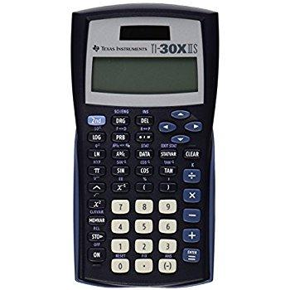
- Interpret functions
- Analyze data

Supplies
Please bring the following materials to class each day (unless otherwise instructed):
- Chromebook and charger
- 5 Subject Notebook
- Pencils, pens, and highlighters (used primarily as note-taking tools)
- Scientific calculator (Texas Instruments TI30XIIS model is recommended – approx. $12)
- 3-ring binder, folder, or something to organize handouts

Keys for Success
- Take notes over all lectures and discussions
- Turn in completed work on time
- Study for proficiency checks and exams
- Contribute to class discussions
- Actively engage in learning

Be POSITIVE and Give your Best EFFORT.
Classwork – Assignments, Homework Quizzes, Activities (10% of your grade)
You will be expected to complete assignments for this course daily. These assignments allow you the opportunity to practice the skills taught during class. Assignments will be checked on a regular basis. You will also be given open note pop quizzes periodically.

No classwork will be accepted for credit after the summative assessment has been taken for the unit.

Classwork Grading
Daily classwork will be graded on a 4 point completion scale. We will go over classwork daily, and students will be expected to mark their own assignment with corrections and ask questions, as needed. The table below shows the breakdown of classwork grading. All work needs to be shown to earn full credit and late work can only earn a maximum of 3 points.
4 out of 4: 100% of assignment is complete with work shown | 3 out of 4: approximately 75% of assignment is complete with work shown | 2 out of 4: approximately 50% of assignment is complete with work shown | 1 out of 4: approximately 25% of assignment is complete with work shown | 0 out of 4: less than 25% of assignment is complete with work shown

Formative Assessments – Proficiency Checks (20% of your grade)
Within each unit, you will be given the opportunity to demonstrate understanding through proficiency checks. Each proficiency check can be retaken one time and must be done within one week. Retakes will be arranged on an individual basis and may require mandatory tutoring. There will be no maximum score limitations placed on retake attempts.

Summative Assessments – Unit Tests (70% of your grade)
In this course, summative assessments are given at the end of each unit. Summative Assessments cannot be retaken.

Course Grades
Each six-week grade is cumulative. The semester grade is then calculated using 90% of the cumulative course grade and 10% of the final exam grade. The grade at the end of the semester is calculated towards your GPA.

RPHS Grading Policy
A 93-100 B- 80-82 D+ 68-69
A- 90-92 C+ 78-79 D 63-67
B+ 88-89 C 73-77 D- 60-62
B 83-87 C- 70-72 F 0-59

LATE WORK POLICY (See RPHS Policy)
At Raymore-Peculiar High School, academic achievement, student responsibility, and student success are of paramount importance. Therefore, all assignment deadlines will be strictly adhered to as defined by the classroom teacher. Students who fail to submit any work at the time of a deadline can expect that a zero will be entered for their grade.

Extra Help
Students may come in for extra help whenever needed. Please try to schedule times with me in advance in order to avoid schedule conflicts.

